Linear Regression 2.2:
Predicting Goals Scored by a Team in a FIFA World Cup 2026 Match

1. Introduction
This analysis explores if pre kick-off information can predict the number of goals teams score during FIFA World Cup 2026. Goals are an attractive outcome to predict as they are highly relevant to the match result and serve as a clear measure of attacking performance. The analysis will utilise the 208 team-match observations that come from having two observations for each of the 104 matches included in the analysis. The primary question this project seeks to answer is if team strength, form, host advantage and squad traits explain variation in goals scored. The secondary question is if an ordinary least squares or Poisson regression model better suits this outcome variable.

2. Data and explanatory variables
This dataset had 208 rows representing one team's statistics for one match. The response variable was that team's number of goals scored. Eight explanatory variables were chosen. Four of them were the same as Linear Regression 2.1 (RankPointsDiff, HostAdvantage, FormGoalsForDiff, FormGoalsAgstDiff). The other four are SquadAvgCapsDiff, SquadAvgIntlGoalsDiff, SquadAvgHeightDiff, and OverseasClubShareDiff. Each of these variables compares the team to their opponent prior to the match-up. Data is entered such that positive values indicate an advantage to the team of interest. The mean for every predictor variable is zero because each of the 104 matches appeared twice, one with a positive sign and the other with a negative sign, thus averaged at 0. They were chosen because they quantify team strength, recent form, experience, height, and international experience, and are available prior to kick-off. Descriptively, teams scored an average of 1.48 goals per team-match, with a standard deviation of 1.39 and a range of 0 to 7 goals.
Variable | Description | Mean | SD | Min | Max
GoalScored | Number of goals scored | 1.481 | 1.393 | 0.000 | 7.000
RankPointsDiff | FIFA ranking points (11 June 2026 ranking) | 0.000 | 237.464 | −506.160 | 506.160
HostAdvantage | +1 if the home team is a host in its own country, -1 if the away team is, else 0 | 0.000 | 0.354 | −1.000 | 1.000
FormGoalsForDiff | Goals scored per match in earlier 2026 matches | 0.000 | 0.824 | −3.000 | 3.000
FormGoalsAgstDiff | Goals conceded per match in earlier 2026 matches | 0.000 | 0.772 | −3.000 | 3.000
SquadAvgCapsDiff | Player’s average international appearance per Squad | 0.000 | 12.022 | −36.808 | 36.808
SquadAvgIntlGoalsDiff | Average international goals of each player in a Squad | 0.000 | 2.580 | −6.962 | 6.962
SquadAvgHeightDiff | A team’s average height | 0.000 | 3.014 | −7.692 | 7.692
OverseasClubShareDiff | Portion of players playing for clubs abroad | 0.000 | 0.407 | −0.962 | 0.962
Table 1. Descriptive statistics for GoalScored and the eight explanatory variables (n = 208). Source: descriptive_statistics.csv.

3. Exploratory analysis
Goal distribution is a count distribution that is highly right skewed given most observations of team-match combinations result in low goal totals, with only occasional games resulting in very high goal counts. The variance ( ~1.94 ) is also larger than the mean (~1.48) and 26% of the match observations had an average of zero goals scored as depicted in Figure 1 below. This pattern is relevant because OLS assumes a continuous outcome which can result in hypothetical negative predictions, while Poisson regression assumes a count outcome. Thus, both models were run to compare the performance.
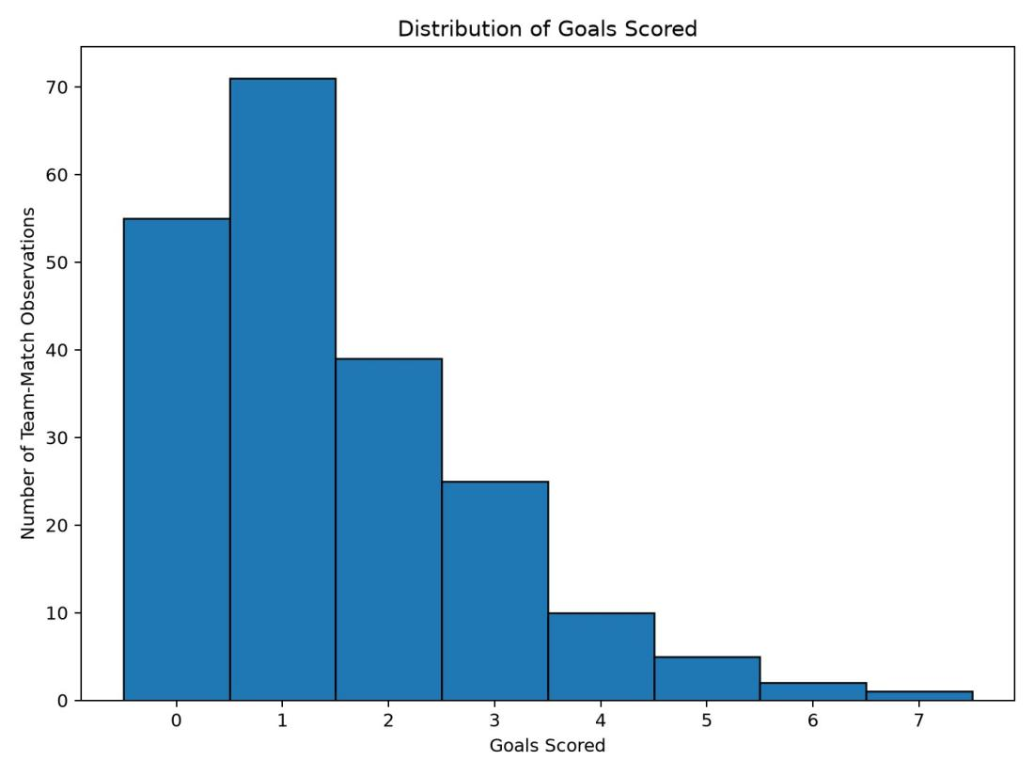 | 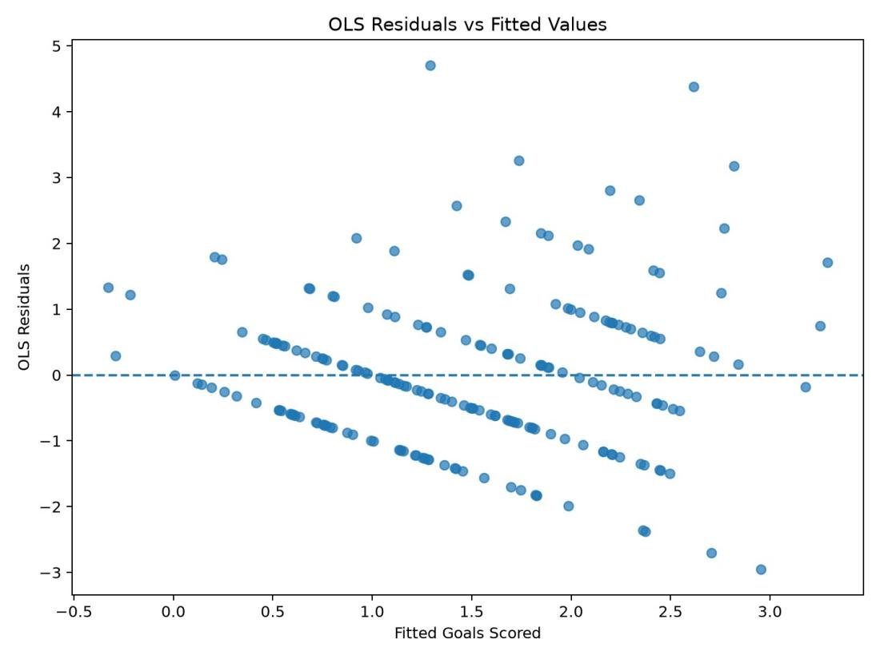 | 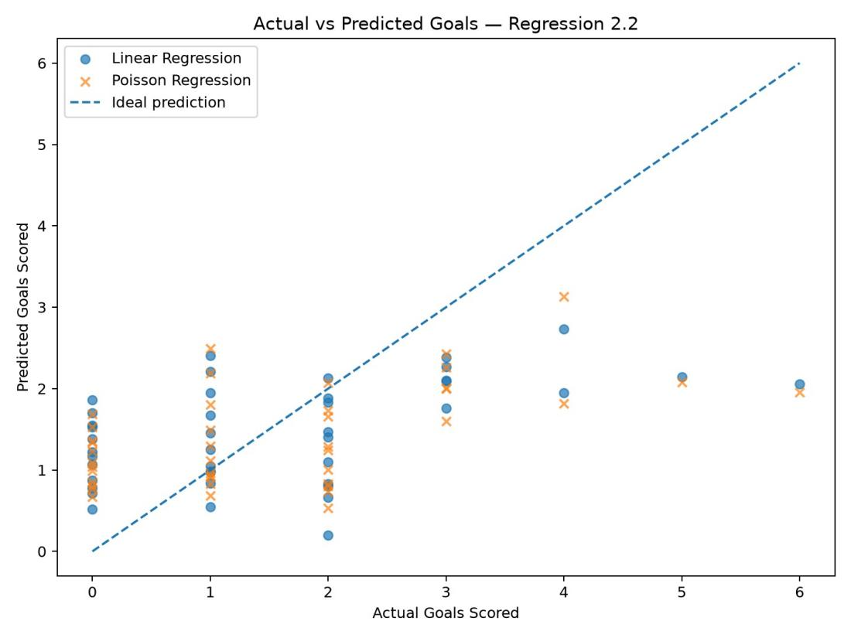
Figure 1. Distribution of goals scored (n = 208 team-match observations). | Figure 2. OLS residuals against fitted values (eight-predictor model, full data). | Figure 3. Actual against predicted goals for the 42 hold-out rows, OLS and Poisson.

4. Methodology
Data splitting was done by match instead of row because teams playing in a match were required to stay together in either the training or hold-out sample. The hold-out sample ended up with 42 total team observations from 21 matches. The training sample had 166 observations from 83 matches. Random seed 42 was used to perform the split. Multiple linear regression was estimated using ordinary least squares. A Poisson generalized linear model was also estimated since the outcome is a count. Graphs were utilized to look at the distribution of goals, predictor-goal relationships, and residuals from the OLS model. Plots were assessed for skewness, potential non-linearity, and linear model assumption issues. Cluster robust standard errors were calculated by MatchID to account for match level clustering (since the two observations from each match are technically not independent). Model performance was compared using MAE, RMSE, R², and AIC.

5. Results
Predictor (TeamVsOpponent) | MLR Coefficient | Robust_SE | p_value | Poisson Coefficient | Robust_SE | p_value
const | 1.4808 | 0.0932 | <0.001 | 0.2611 | 0.0708 | <0.001
RankPointsDiff | 0.0030 | 0.0005 | <0.001 | 0.0021 | 0.0003 | <0.001
HostAdvantage | 0.4924 | 0.2688 | 0.0670 | 0.3510 | 0.1814 | 0.0530
FormGoalsForDiff | -0.1685 | 0.1006 | 0.0939 | -0.1107 | 0.0651 | 0.0892
FormGoalsAgstDiff | -0.1171 | 0.1076 | 0.2761 | -0.0777 | 0.0711 | 0.2744
SquadAvgCapsDiff | -0.0190 | 0.0082 | 0.0200 | -0.0129 | 0.0055 | 0.0195
SquadAvgIntlGoalsDiff | 0.0592 | 0.0416 | 0.1552 | 0.0397 | 0.0274 | 0.1468
SquadAvgHeightDiff | 0.0194 | 0.0247 | 0.4327 | 0.0119 | 0.0167 | 0.4760
OverseasClubShareDiff | 0.2435 | 0.2059 | 0.2371 | 0.1647 | 0.1378 | 0.2323
Table 2. Coefficients of the eight-predictor OLS and Poisson models (cluster-robust standard errors by MatchID)
The OLS model accounted for 28.7% of variance in goals with adjusted R² = 25.8%. The overall model was significant, F = 11.46, p < .001. RankPointsDiff was the only strong significant predictor (b = 0.0030, p < .001). As mentioned previously, this indicates that a larger predicted ranking advantage was associated with larger predicted values for goals scored. SquadAvgCapsDiff was also significant, but opposite in sign (b = −0.0190, p = .020). HostAdvantage approached significance (p = .067), but FormGoalsForDiff, FormGoalsAgstDiff, SquadAvgIntlGoalsDiff, SquadAvgHeightDiff, and OverseasClubShareDiff did not achieve statistical significance. With the Poisson model, the same main pattern emerged. RankPointsDiff and SquadAvgCapsDiff were significant predictors.

6. Model evaluation and comparison
The comparison of OLS models improves slightly when the four squad variables are added. Compared with the four-predictor model, the eight-predictor version reduced hold-out MAE from 1.036 to 1.012 and RMSE from 1.309 to 1.267. Hold-out R² increased from 0.186 to 0.237. This finding implies that the squad variables contribute some information over and above the four predictors that both models use. The eight-predictor models were tested against each other using the same 21-match hold-out sample. Poisson regression appears to provide a marginally better prediction than OLS, with a lower MAE (0.985 compared with 1.012), lower RMSE (1.242 compared with 1.267), and higher R² (0.267 compared with 0.237). Poisson also had a substantially lower AIC of 611.8 compared with 675.0. Overall, these results confirm that Poisson regression is a better fitting model for predicting goals scored since the outcome variable is a count.

Model | MAE | RMSE | R_squared | AIC_Full_Data
Multiple Linear Regression (4 predictors) | 1.0360 | 1.3093 | 0.1855 | 673.6
Multiple Linear Regression (8 predictors) | 1.0121 | 1.2670 | 0.2373 | 675.0
Poisson Regression (4 predictors) | 1.0046 | 1.2913 | 0.2079 | 610.0
Poisson Regression (8 predictors) | 0.9851 | 1.2421 | 0.2671 | 611.8
Table 3. Hold-out performance of OLS and Poisson Models
OLS residuals were not normally distributed (both Omnibus and Jarque-Bera were significant). Some fanning was observed in the residual plot. Finally, some fitted values were below zero, which were not meaningful for a goals outcome. Durbin-Watson was 1.844, indicating no serious autocorrelation issues. Poisson dispersion was 0.954, close to 1 and therefore indicative of the Poisson model being appropriate. These results, coupled with its superior hold-out performance, led to favour Poisson for goal scoring prediction. Poisson is used because the dependent variable is a count of goals scored, which means it can only assume non-negative whole-number values. Poisson also fit these data better because its dispersion parameter is near 1 and it had lower prediction errors and AIC than the OLS model.

7. Conclusion and recommendations
In summary, before-match information gave some indication as to ability to predict number of goals scored. FIFA ranking advantage gave the most clear-cut indication, followed by squad caps. However, some variables gave no significant independent information once the effects of other predictors were accounted for. Poisson is recommended because goals scored are count data, its dispersion parameter was close to one, and it produced better predictions than OLS on the hold-out sample. These results should be taken with some caution as there are only 104 matches in the dataset. Also, football matches can be influenced by unexpected events unknown until kick-off (or afterwards) such as red cards, penalties, injuries and form of players.

